1. Create a Unity Project

Chrono Ark uses Unity version 2018.4.32f1 (<https://unity.cn/releases/full/2018>), please make sure you create the Unity of the same version.

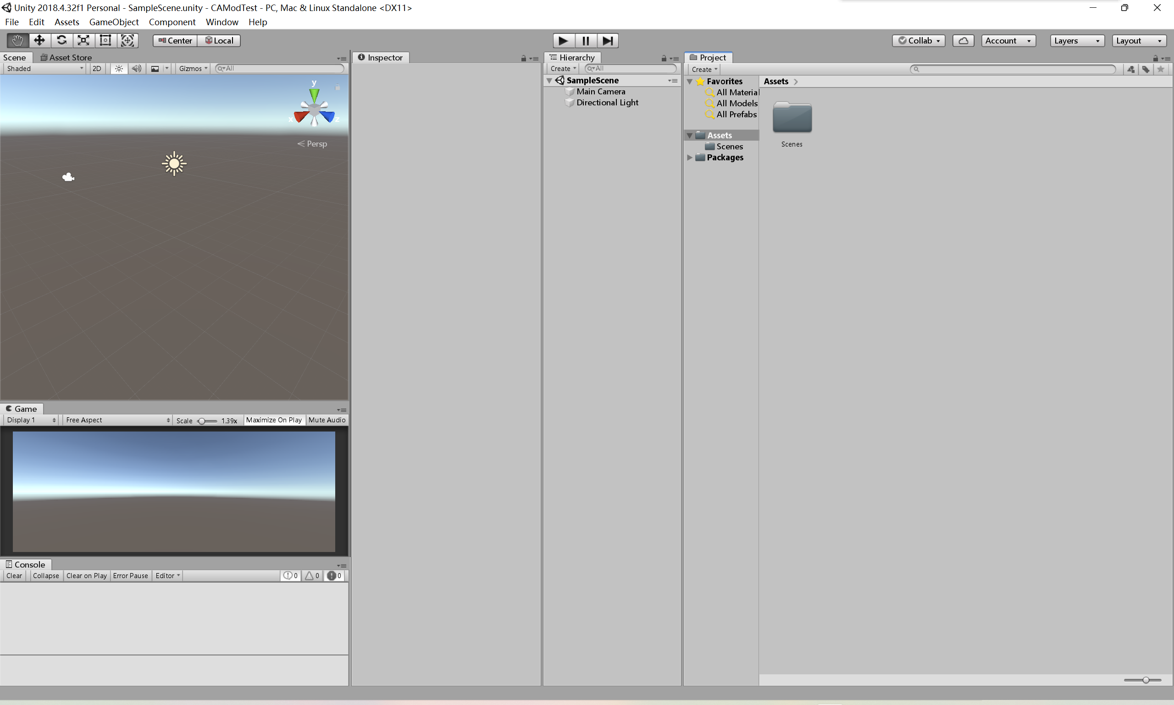

1. Install ThunderKit and Import ChronoArk Program
2. Download [Releases · PassivePicasso/ThunderKit (github.com)](https://github.com/PassivePicasso/ThunderKit/releases) (or directly use the package inside this guide).
3. Go to Unity -> Window -> Package Manager, click “Add package from disk” at the bottom.

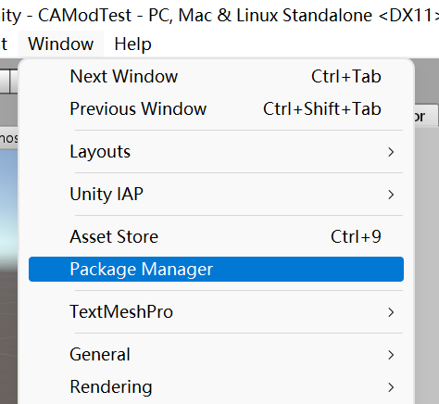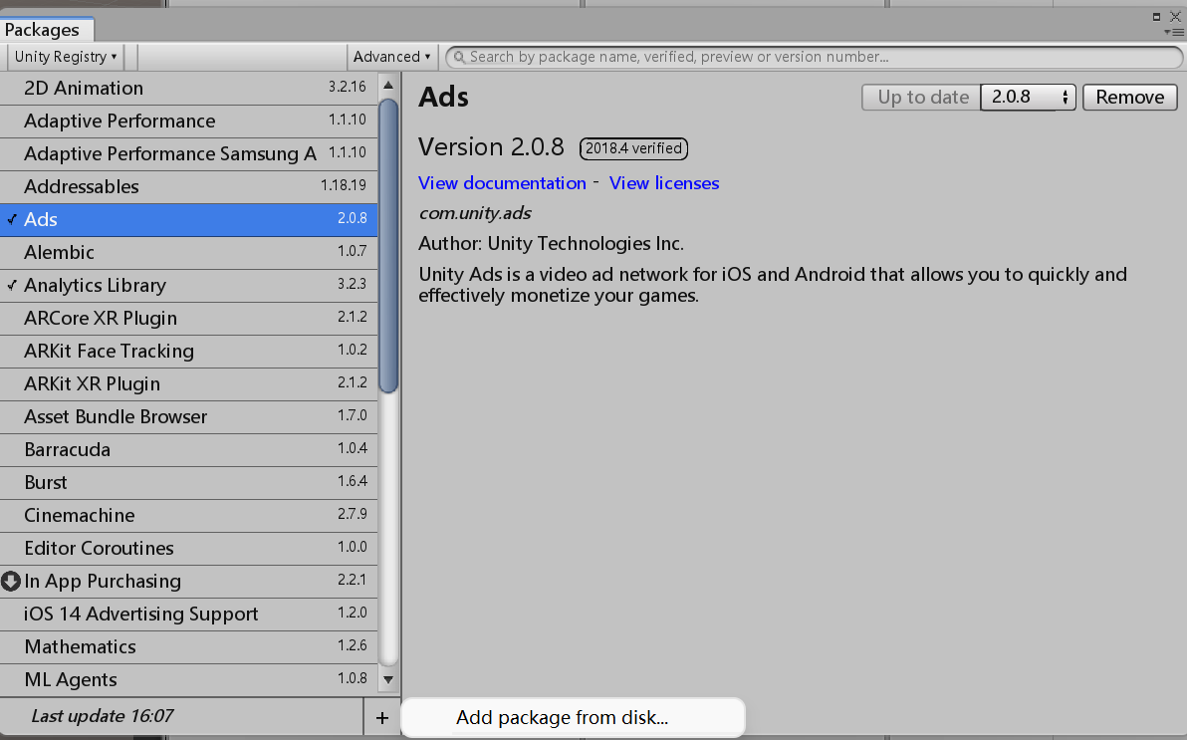

1. Import the package.json file from the ThunderKit package

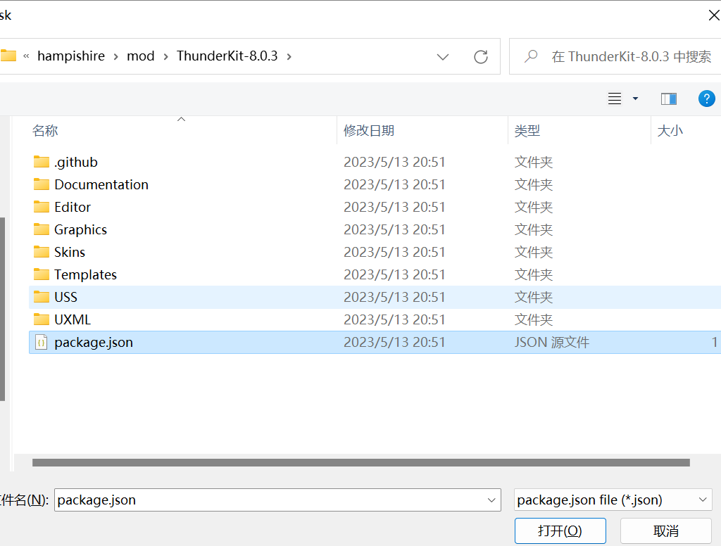

1. A setting window of ThunderKit will show up automatically. You can also access it at the below location.

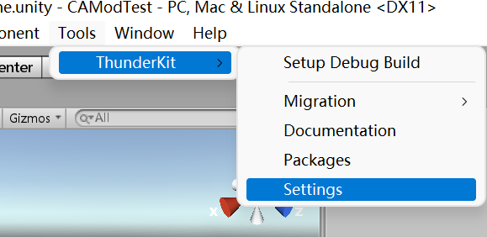

1. In “Import Configuration”, set “Include Settings” to “Everything”, “ImportAddressableCatalog” to “Off”

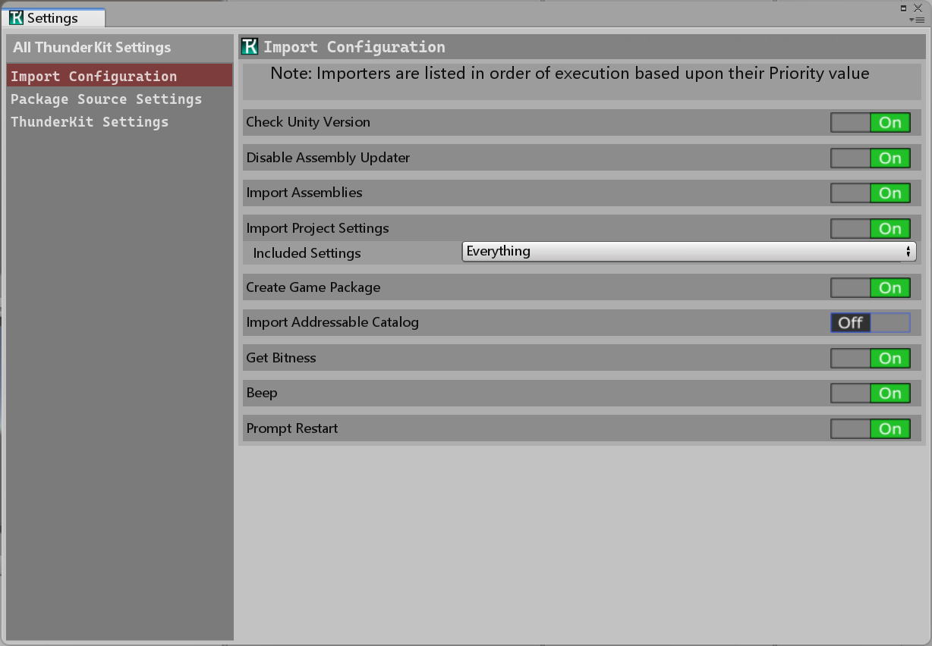

1. Copy Chrono Ark\x64\Master\ChronoArk.exe to the root folder of Chrono Ark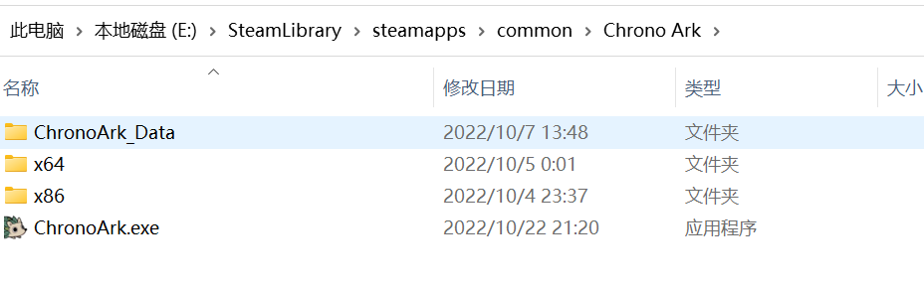
2. In Settings -> ThunderKitSettings, click “Browse” and select copied “Chronoark.exe”

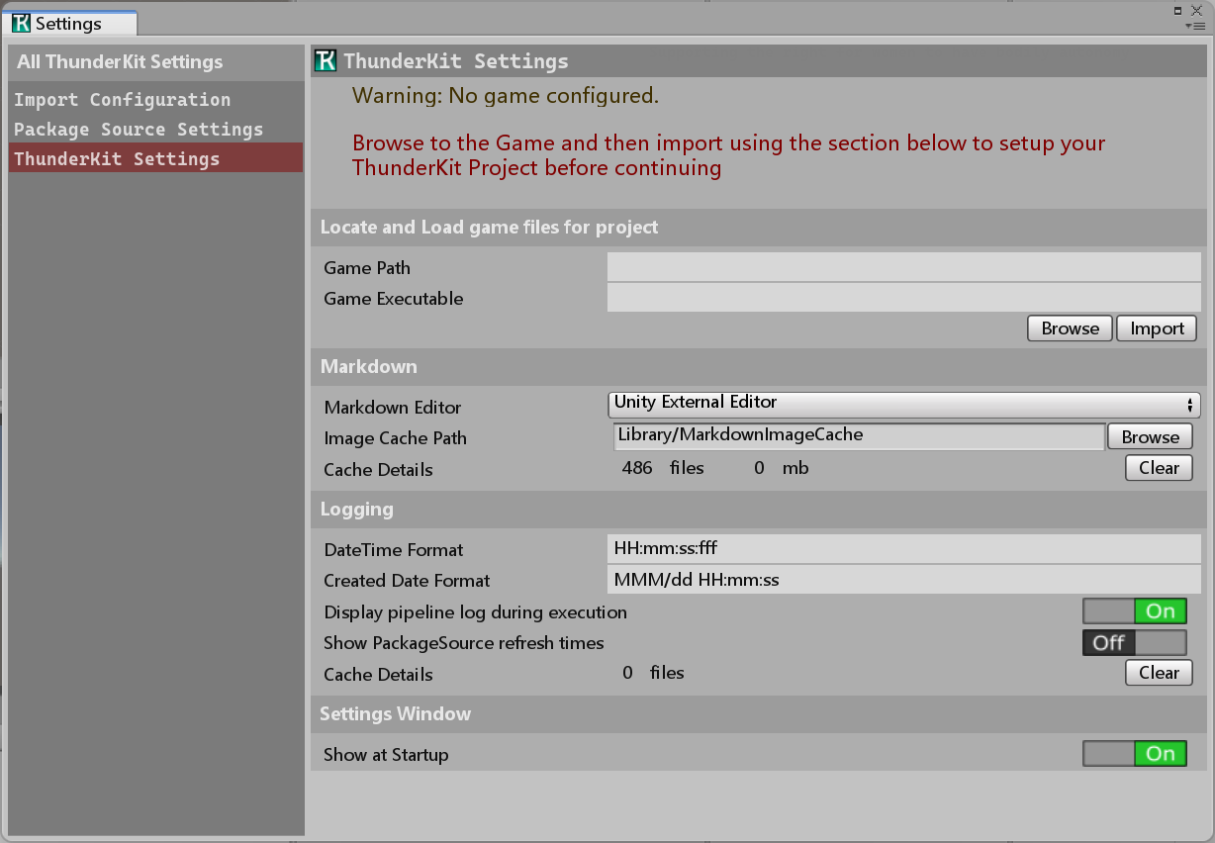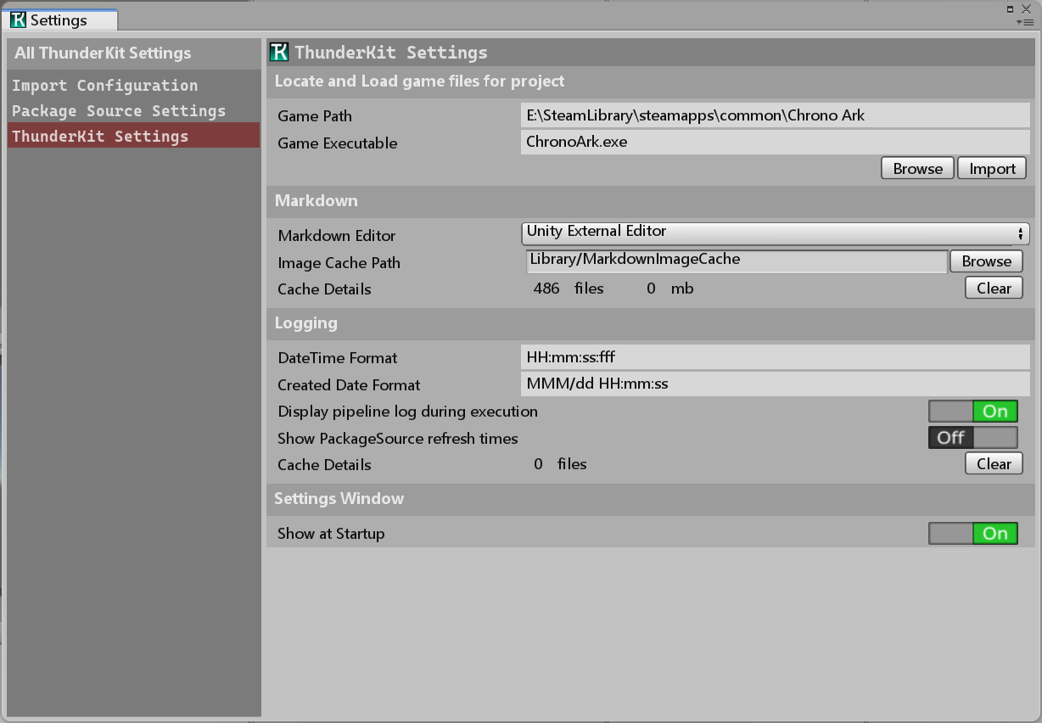

1. Click import, and restart the Unity Editor twice following the instructions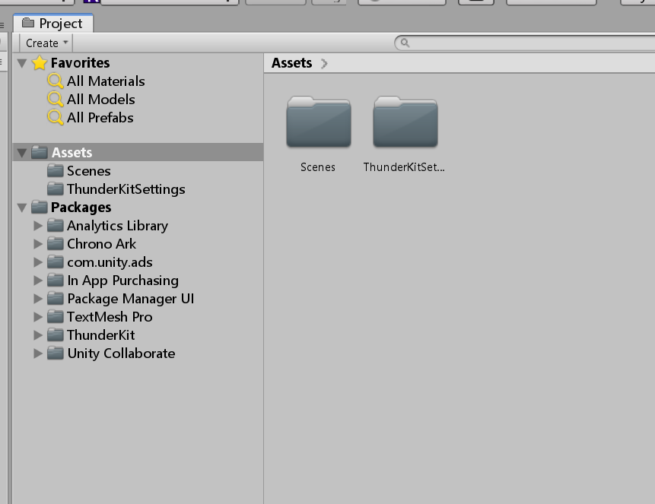
2. Export AssetBundle
3. Create a test folder and add some test items inside. It’s suggested to put everything you want to export in a single folder so it will export everything together.

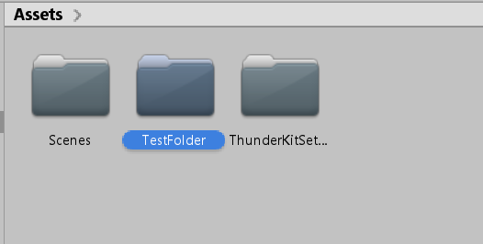 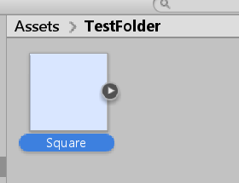

1. In PackageManager, install AssetBundleBrowser. It will take some time to show up in PackageManager. If you can’t find it, it can be downloaded at GitHub similar to ThunderKit.

[Release 1.7.0 · needle-mirror/com.unity.assetbundlebrowser · GitHub](https://github.com/needle-mirror/com.unity.assetbundlebrowser/releases/tag/1.7.0)

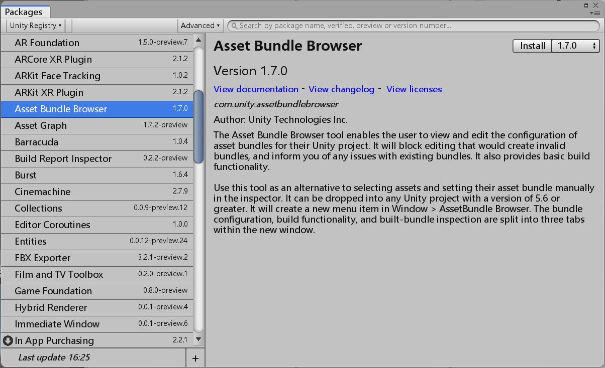

1. Click the item (folder) you want to export, under Inspector the UI of AssetBundle will show up, click to create and name a new AssetBundle

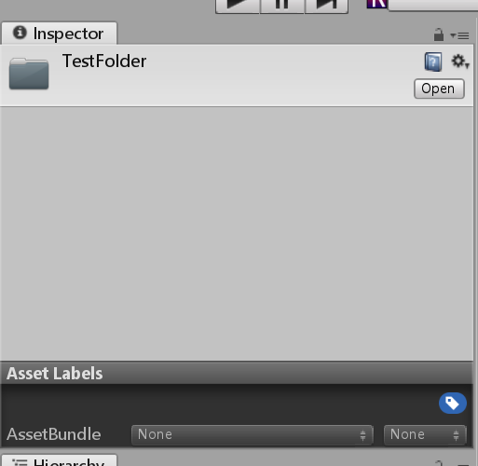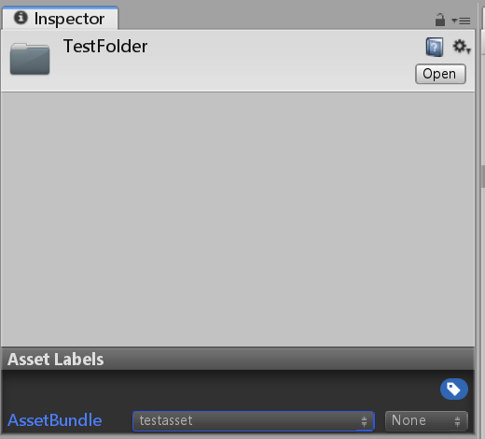

1. In Window -> AssetBundleBrowser, you can check whether the items are in the AssetBundle.

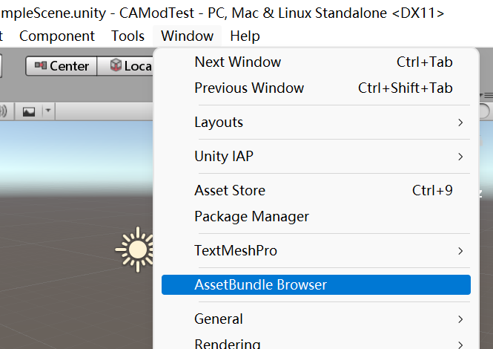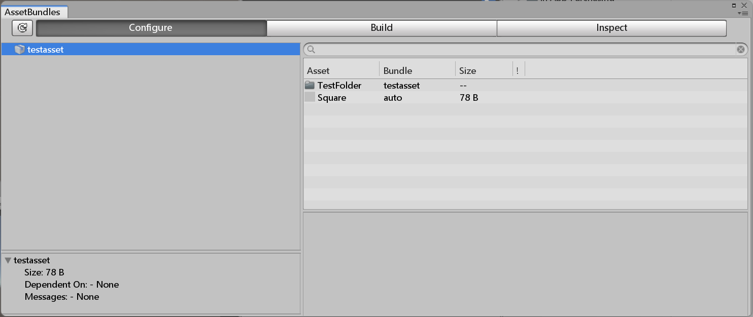

1. Click Build -> Build to create an AssetBundle

